**FAIR HOUSING RESOLUTION**

WHEREAS, under the Federal Fair Housing Law, Title VIII of the Civil Rights Act of 1968, it is illegal to deny housing to any person because of race, color, religion, gender, physical or mental disabilities or national origin; and,

WHEREAS, under the Michigan Elliott-Larsen Civil Rights Act, PA 453 of 1976, as amended, it is illegal to deny the opportunity to obtain housing to any person because of religion, race, color, national origin, age, sex, height, weight, familial status, or marital status;

LET IT BE KNOWN TO ALL PERSONS that it is the policy of Community Action to implement programs to ensure equal opportunity in housing for all persons regardless of religion, race, color, national origin, age, sex, height, weight, familial status, or marital status. Therefore, Community Action does hereby pass the following Resolution:

BE IT RESOLVED that Community Action shall not discriminate in the sale, rental, leasing, or financing of housing because of religion, race, color, gender, physical or mental disabilities, national origin, age, height, weight, familial status, or marital status.

Community Action will assist all persons who feel they have been discriminated against because of religion, race, color, gender, physical or mental disabilities, national origin, age, height, weight, familial status, or marital status to seek equity under federal and state laws by providing information to said persons on how to file a complaint with the Michigan Department of Civil Rights.

Community Action will at a minimum post this policy or the Fair Housing poster or other posters, flyers or other information which will bring to the attention of owners of real estate, developers and builders their respective responsibilities and rights under the Federal Fair Housing Law and Michigan Elliott Larsen Act.

This Resolution shall take effect as of the date listed below.

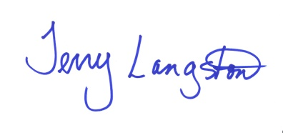

_________________________________________10/25/2010

Terry Langston, Board of Directors Chairperson Date